Ideation Phase
Empathize & Discover
Date | 1 October 2026 | Team ID |
Project Name | Auto ticket classification using flow designer | Maximum Marks | 4 Marks

Empathy Map Canvas:
An empathy map is a simple, easy-to-digest visual that captures knowledge about a user’s behaviours and attitudes. It is a useful tool to helps teams better understand their users.
Creating an effective solution requires understanding the true problem and the person who is experiencing it. The exercise of creating the map helps participants consider things from the user’s perspective along with his or her goals and challenges.
Reference: https://www.mural.co/templates/empathy-map-canvas
Framework Structure Overview:
The Empathy Map Canvas visualizes the user's experience by dividing user insights into four quadrant domains (Says, Thinks, Does, Feels), supported by Pain Points and Goal/Gain metrics
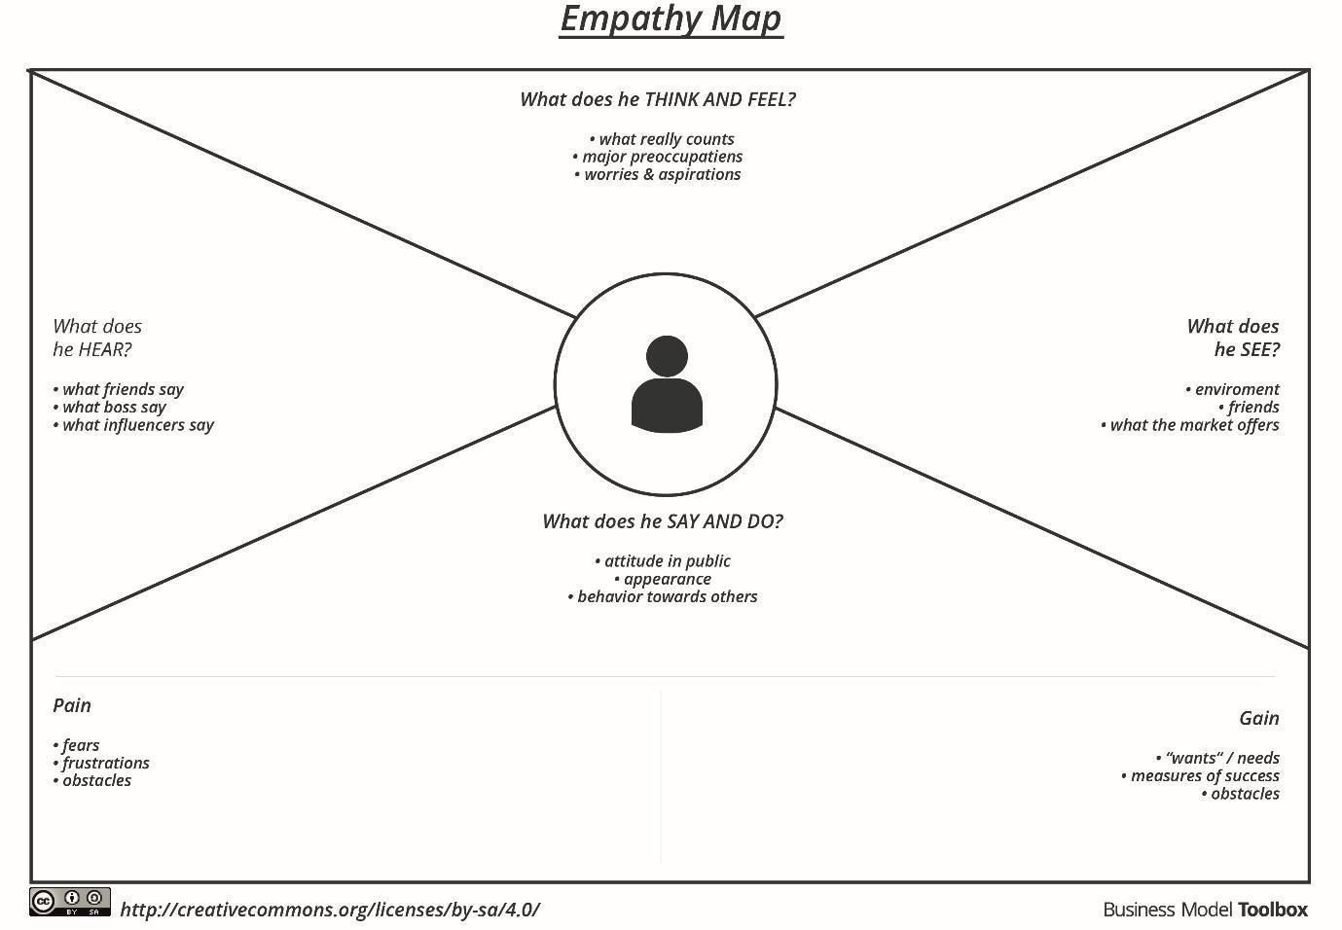

Project-Specific Empathy Map
Target User Persona: Support Agent / IT Helpdesk Team Member
SAYS  • “I’m getting too many tickets to handle manually.”  • “Sometimes tickets are assigned to the wrong group.”  • “I want the classification to be accurate and quick.”  • “I need a better way to handle unmatched tickets.” | THINKS  • “Will the automation classify the ticket correctly?”  • “Will it reduce my manual workload?”  • “Will the process save time?”  • “What happens when the ticket details are incomplete?”
DOES  • Reads the ticket title and description.  • Checks category and ticket details.  • Manually classifies incoming tickets.  • Assigns tickets to the appropriate assignment group.  • Handles unmatched or exceptional tickets.  • Uses ServiceNow tools to monitor and track tickets. | FEELS  • Overwhelmed by high ticket volume.  • Frustrated when tickets are misclassified.  • Stressed when ticket resolution is delayed.  • Relieved when automation reduces repetitive work.  • More confident when tickets are routed correctly.

PAIN POINTS  • Manual ticket classification takes time.  • Tickets may be assigned to the wrong category or group.  • High ticket volume increases workload.  • Unclear or incomplete ticket details make classification difficult.  • Unmatched and exceptional tickets still require manual handling. | GOALS  • Automatically classify incoming support tickets.  • Route tickets to the correct assignment group.  • Reduce manual effort and save time.  • Improve classification consistency and speed up resolution.

ServiceNow Auto Classification Flow Pipeline:
📥 Step 1  Incoming Support Tickets | ⚡ Step 2  Flow Designer Engine | 🏷️ Step 3  Auto Classification | 🔀 Step 4  Smart Routing | 👥 Step 5  Correct Support Group

